Nama : MELSANDY TARIGAN

Nim : 1301174217

Kelas : IF 41-01

Laporan Test Case

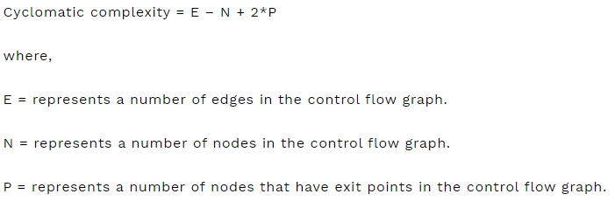

1. Hasil Skor Tertinggi

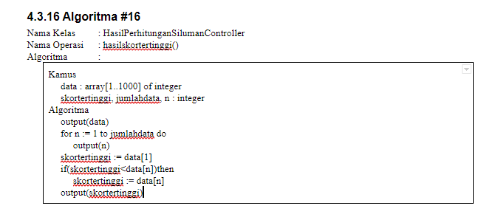

1. Control Flow Graph :

Edge = 7

Node = 7

Exit Point = 1

Cyclomatic Complexity = E – N + 2 * P

= 7 – 7 + 2 * 1

= 2

1. Test Case

|  |  |  |  |
| --- | --- | --- | --- |
| Test Case | Pre-requisitest | Steps | Expected Result |
| User sudah berhasil menyelesaikan game perhitungan siluman | User berada di halaman hasil perhitungan siluman | User bisa melihat dan mengecek skor tertinggi yang sudah ada | Data skor tertinggi akan tersimpan di dalam database |

1. Hasil Skor Terendah

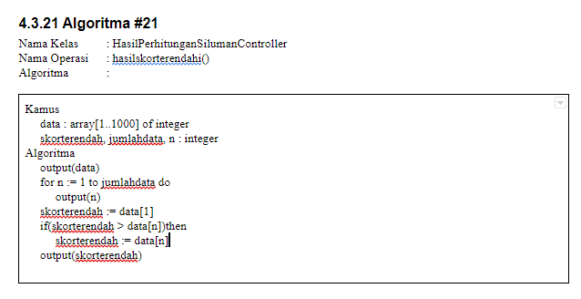

1. Control Flow Graph

Edge = 7

Node = 7

Exit Point = 1

Cyclomatic Complexity = E – N + 2 * P

= 7 – 7 + 2 * 1

= 2

1. Test Case

|  |  |  |  |
| --- | --- | --- | --- |
| Test Case | Pre-requisitest | Steps | Expected Result |
| User sudah berhasil menyelesaikan game perhitungan siluman | User berada di halaman hasil perhitungan siluman | User bisa melihat dan mengecek skor terendah yang sudah ada | Data skor terendah akan tersimpan di dalam database |